PROJECT PROPOSAL

COURSE: SOFTWARE ENGINEERING
FACULTY: MISS FAIZA JAVED
PROJECT: HOSPITAL MANAGEMENT SYSTEM

GROUP MEMBERS
HAFIZ MOHAMMED MIZFAR (19229)
MOHAMMED SHAKIR HASAN KHAN (15842)
HUMZA AHMED (15841)

HOSPITAL MANAGEMENT SYSTEM

Scope:
A Hospital Management System (HMS) is designed to manage all hospital operations efficiently, including patient registration, appointment scheduling, and medical records management. It also handles billing, staff management, pharmacy inventory, and laboratory test tracking. The system ensures secure storage of patient information, provides reports for hospital operations, and integrates with external systems like insurance and diagnostic labs. HMS streamlines workflows, improves patient care, and ensures data security and health regulations.
Problem Statement:
Hospitals often face challenges in managing patient records, appointments, billing, and inventory efficiently due to manual or outdated processes. This can lead to errors, data loss, and delays in patient care. A centralized, digital system is needed to simplify these tasks, improve accuracy, and provide secure access to information, ultimately enhancing the overall patient experience and hospital operations.
Proposed Solution:
Hospital Management System (HMS) that centralizes all hospital operations. This system will handle patient registration, appointment scheduling, billing, medical record management, and inventory control. It will also enable secure access for staff based on roles, improve data accuracy, and automate routine tasks, reducing errors and saving time. HMS workflows and enhance overall patient care.
Key Features includes:
User-Friendly Interface:
A simple and intuitive interface makes it easy for staff to navigate and complete tasks efficiently.
Real-Time Data Access:
Staff can access updated information instantly, allowing faster decision-making and patient care.
Data Security and Privacy:
Data is protected through secure access controls, ensuring that only authorized users can view or edit sensitive information.
Scalability:
The system can grow with the hospital, adapting to increased data, users, and functionality needs over time.

Objectives :
Online System:
Provides a digital platform accessible from anywhere, allowing users to manage hospital tasks like appointments, billing, and record-keeping online for better efficiency and convenience.

Appointment Management: Enables easy scheduling, rescheduling, and canceling of appointments, reducing wait times and improving patient service.

Medical Record Maintenance: Stores and organizes patient medical history, making it easy to access and update for ongoing and future treatments.

Billing:
Automates billing for treatments and services, generating accurate invoices and streamlining payment processing.

Pharmacist:
Manages medicine inventory, prescription tracking, and dispensing, ensuring medications are available and correctly issued to patients.

Laboratory:
Tracks and schedules lab tests, records results, and provides secure access to reports for both patients and doctors.

Doctor:
Allows doctors to view patient histories, manage appointments, and record diagnoses and treatments, improving patient care.

Receptionist:
Manages patient registration, appointment scheduling, and assists with patient inquiries for smooth front-desk operations.

Lab Report:
Sharing of lab reports with patients and doctors, improving communication and patient care.

Patient:
Patients can book appointments, view test results, and access their medical records online, providing greater control over their healthcare.

STAKE HOLDERS AND USERS:
- Stake holders: A stakeholder is a person, group or organization with a interest, or stake, in the decision-making and of a business,organization and project.Every stake holder cannot be user.
- User: user who uses the systemand managed by the hospital every user is a stake holder.
STAKE HOLDERS | USERS
- Pharmacist | - Pharmacist
- Laboratory | - Laboratory
- Doctor | - Doctor
- Patient | - Patient
- Recpionist | - Recpionist
- Pune
- Ambulance
- Canteen
- Nurses

Users Narration/ Task List:
Users: Laboratory, Doctor, Pharmacist, Patient, Receptionist.
Laboratory:
The person who is the patient data information and the test details with the help of hospital management system laboratory personnel treats patient diseases they conduct the test the results in soft copy. Through the application test report soft copy is sent to the doctor.
Doctor:
With the help of an application doctor has patient health detail, earlier appointment detail, medicines detail and according to patient health doctor update patient health with the help of system and application with maintaining the patient health history.
Pharmacist:
Pharmacist person automatically with the help of application system they receive prescription from doctor without making any slip or recipt and pharmacist person maintain patient medication detail updates , check inventory ,check supplies and update it.
Patient:
Patient With the help of the software, patients can handle schedule appointments, select the doctor and timing, view their health history, check last bill history, and view their prescription.
Receptionist:
With the help of an application receptionist can search patient health history check patient schedules and the status of the payment of the patient.

Hospital Management System (HMS), 10 functional and 10 non-functional requirements:
Functional Requirements: | Non-Functional Requirements:
1. User Authentication: The system should allow doctors, patients, pharmacists, laboratory staff, and receptionists to log in using credentials. | 1. Performance: The system quick respond to user requests within 2 to 5 seconds under normal load conditions.
2. Appointment Scheduling: Patients should be able to request and schedule appointments, while doctors can approve or rejects them. | 2. Scalability: The system should support up 500 to 600 current users without significant performance degradation.
3. Health Records Management: Doctors should have access to view and update patient health records. | 3. Security: All user data, including health records and payment information, must be encrypted and stored securely to prevent unauthorization access.
4. Test Management: Laboratory staff should be able to view, update, and manages test orders and results. | 4. Availability: The system should be available 99.9% of the time, with planned maintenance announced in advance.
5. Prescription Management: Doctors should be able to create, update, and review prescriptions, which the pharmacist can view and dispensed accordingly. | 5. Usability: The system should have an user-friendly interface, accessible to users with basic knowledge about computer skills.
6. Payment Processing: Patients should be able to view payment history, pay bills, and get confirmation for successful payments. | 6. Data Integrity: The system must ensure that data entered by one user is consistent and correct across all modules and objects.
7. Inventory Management: Pharmacists should be able to update and manage drug inventories. | 7. Compliance: The system must follow These regulations, such as (HIPAA)  Health Insurance Portability and Accountability Act and (GDPR) General Data Protection Regulation
8. Notifications and Alerts: The system should notifies doctors, patients, and staff about appointments confirmations, test results, and other important updates. | 8. Backup and Recovery: Regular backups should be scheduled, and the system must be able to recover data in case of failure within 5 to 6 hours.
9. Patient History View: Patients and doctors should be able to view the patient’s health history at any time. | 9. Cross-Platform Compatibility: The system should be accessible from multiple devices, including desktops, tablets, and mobile devices, across different operating systems.
10. Report Generate: The system should generate reports on patient tests, doctor appointments, and inventory usage for administrators and staffs management. | 10. Reliability: The system should be resilient to hardware failures and should continue to function without data loss and data corrupted.

ACTOR DIAGRAM:

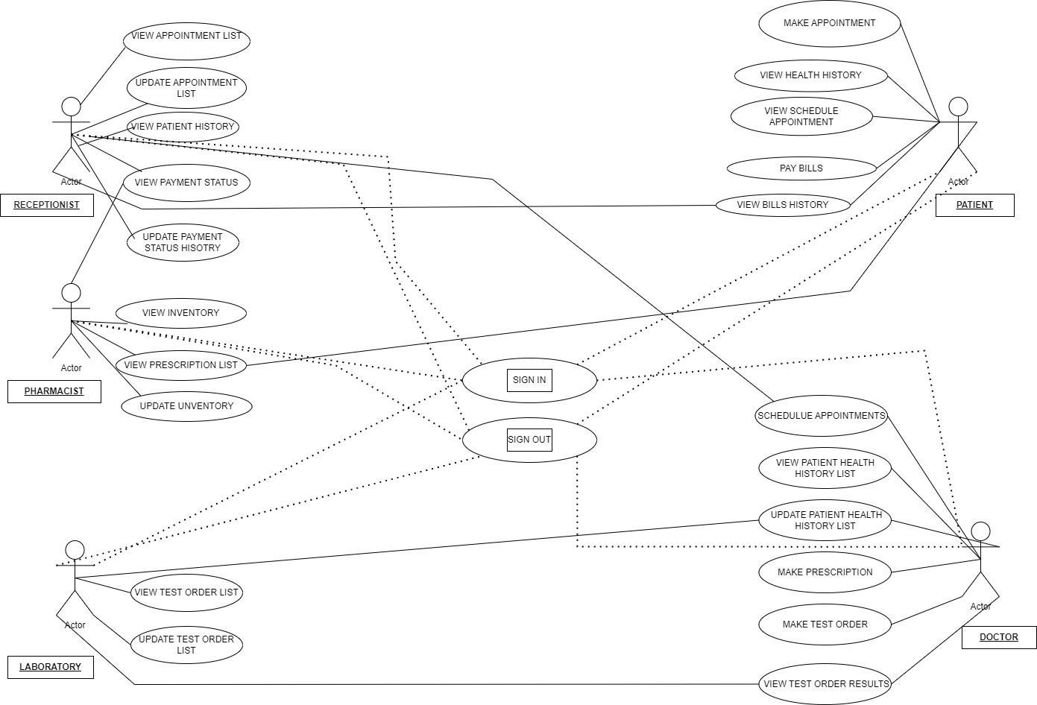

CONTEXT DIAGRAM:
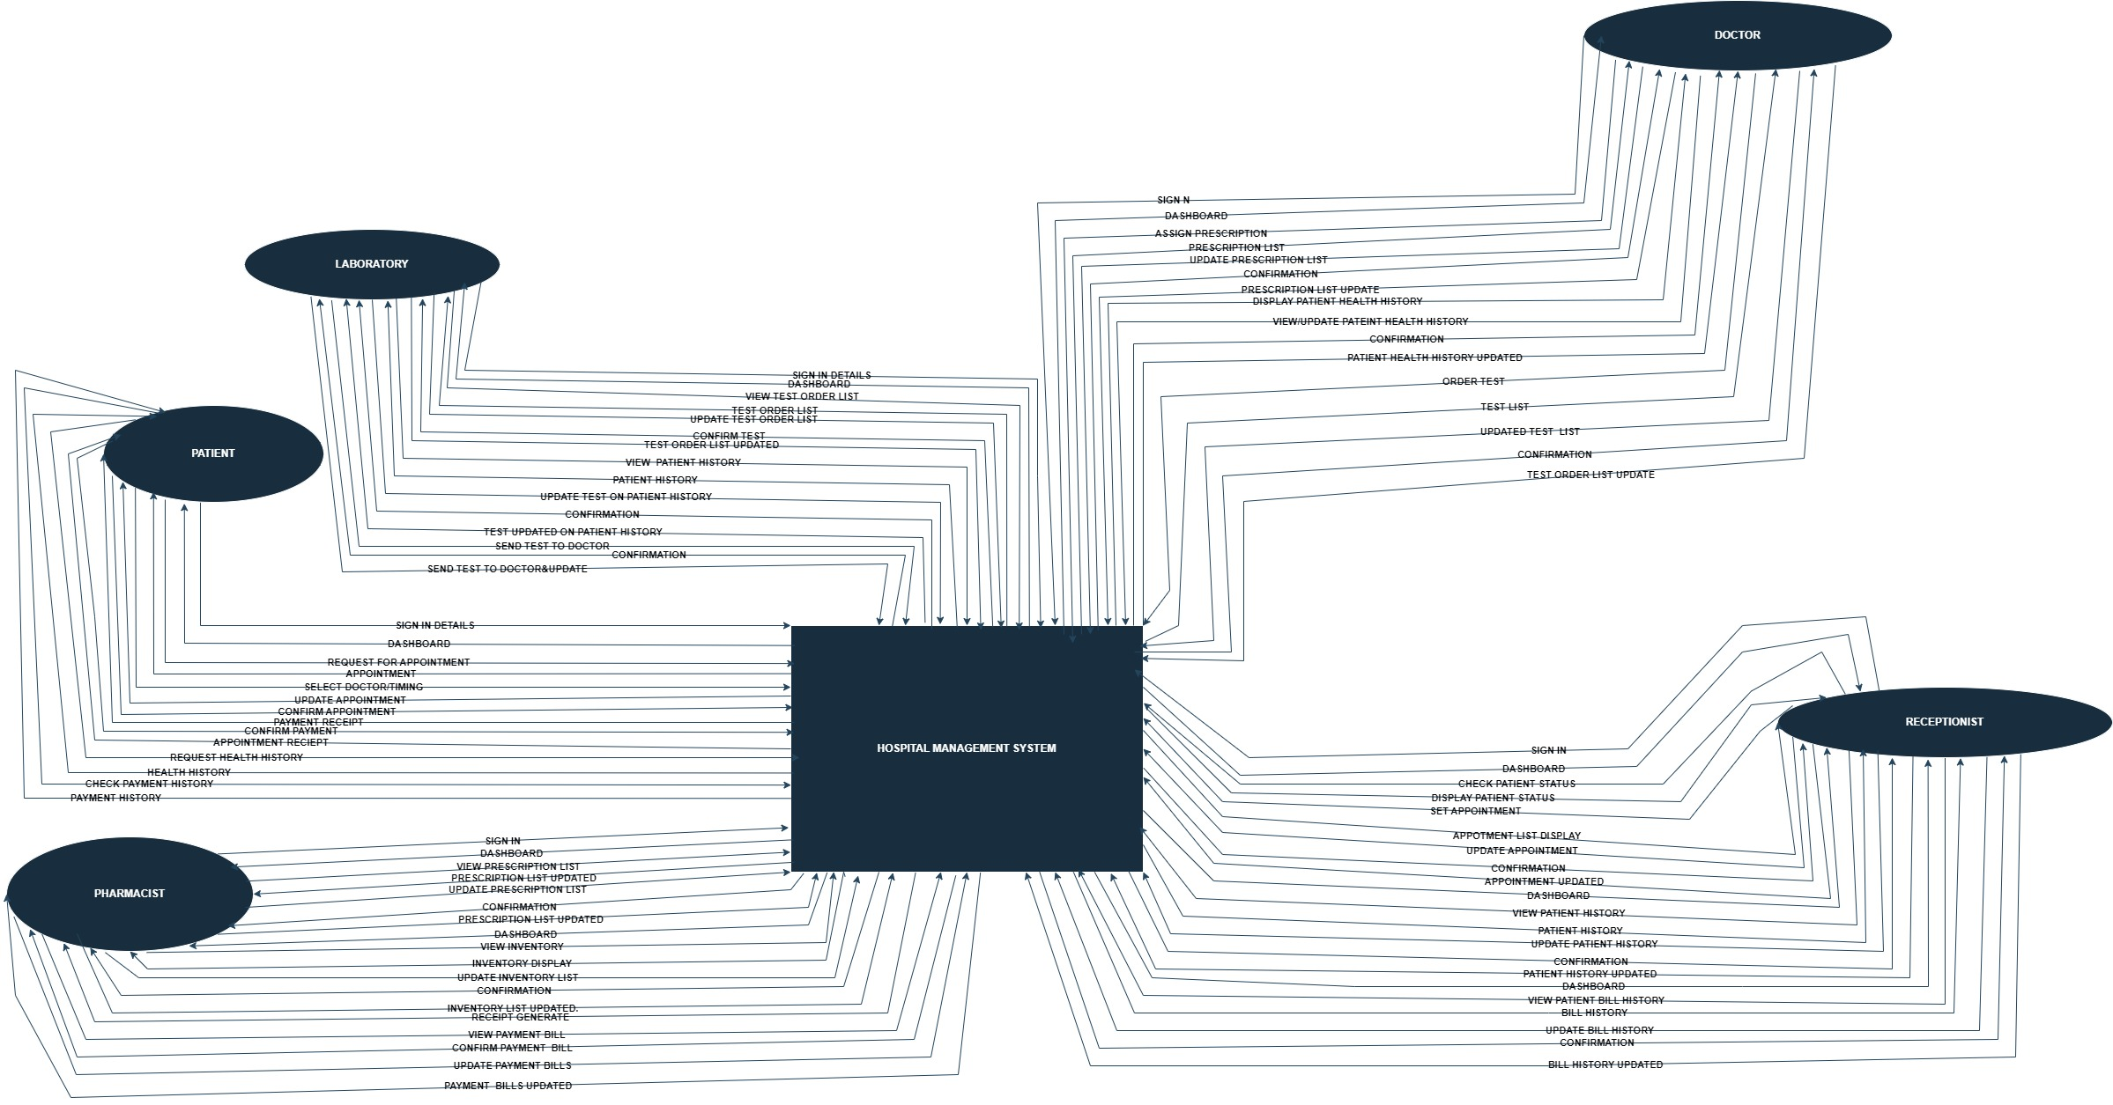

WORKFLOW DIAGRAM:
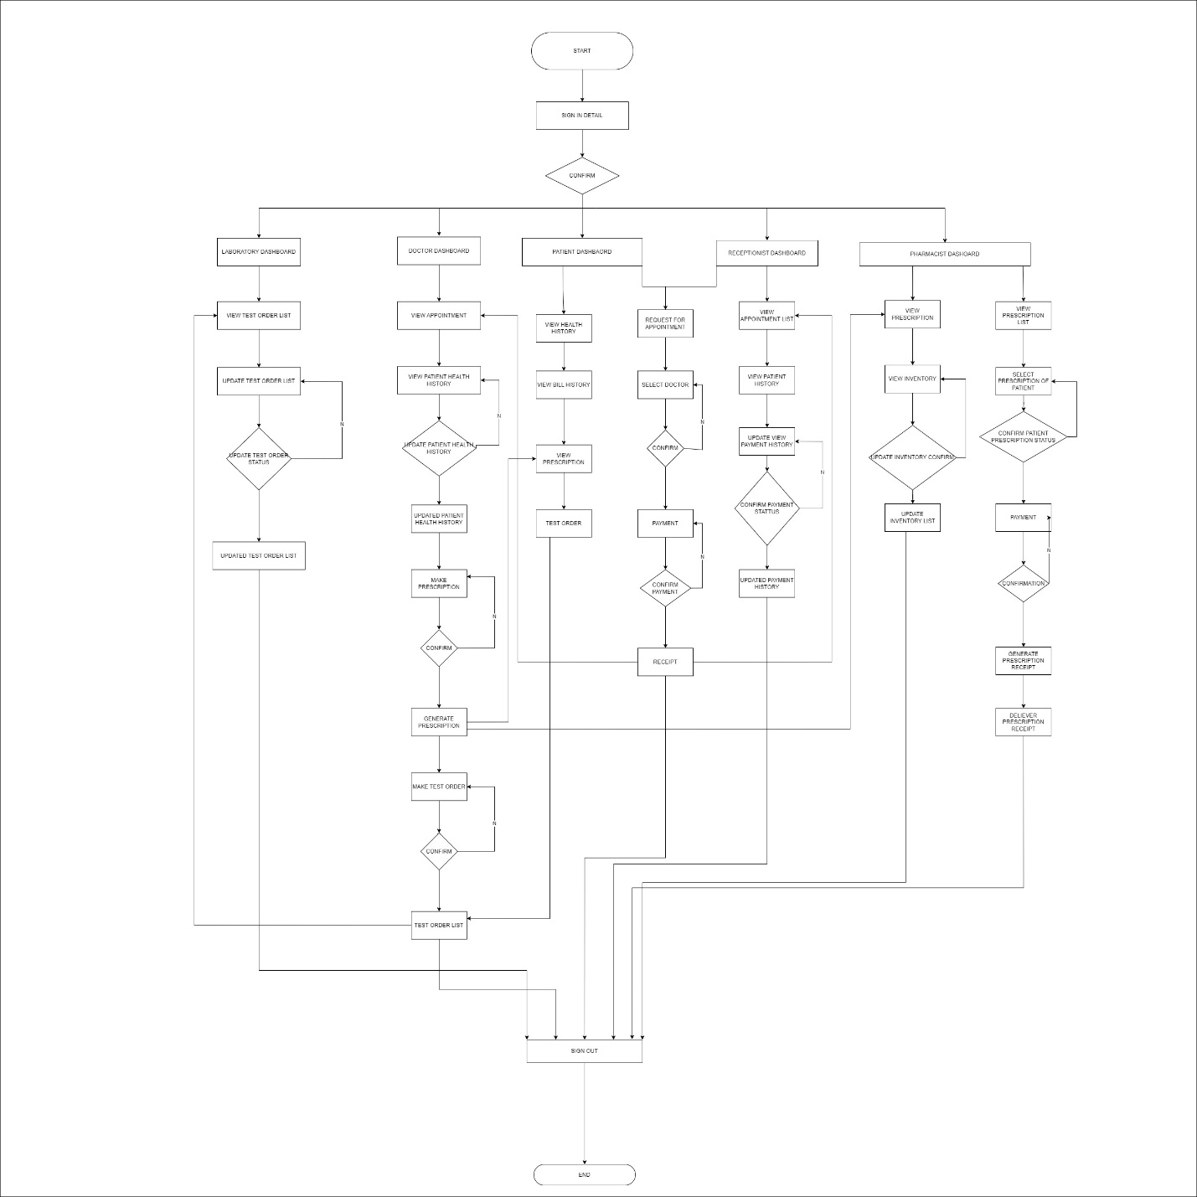

SEQUENTIAL DIAGRAM:
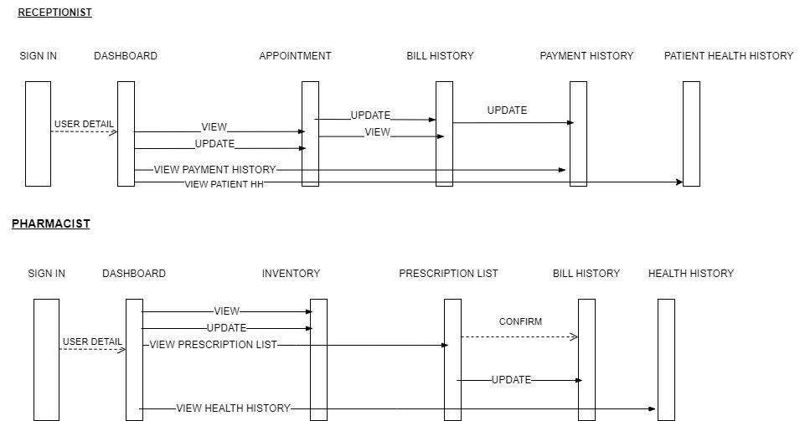

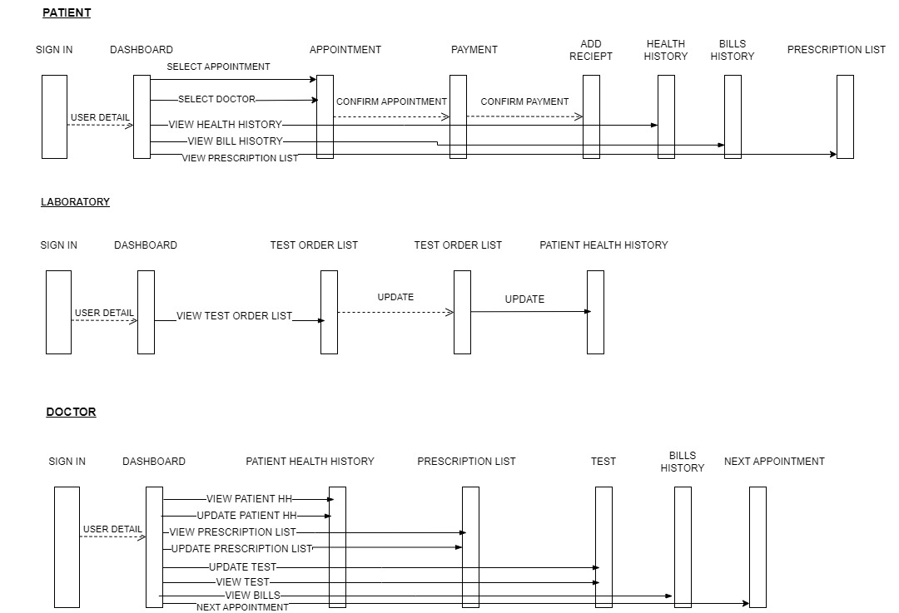

USE CASES:
Appointment:
Use case ID | 1001 | Date | 20-12-2024
 |  | Duration | 2-5 minutes
1: Task Name  2: Description  3: priority  4: Frequency of use  5: Actor  6: Pre-Condition  7: Post-Condition  8: Acceptance criteria  9: Alternatives  10: Assumption  11: Constant And  Special requirements  12: Organizational Benefits | Appointment  Patient set an appointment online with specific time duration  Medium  Low  Patient  Before appointment patient must have access to dashboard  After appointment receipt generated of the confirm appointment  For selecting appointment, we need to select Doctor, Date, Time and Check fees  If online appointment not done user can take appointment by visiting hospital from reception  For appointment we needed internet and registered patient  They are always required during the daily operations of the hospital  Brings organizational benefits, including enhanced operational efficiency, improved patient experience, better resource management

Patient online Health History:
Use case ID | 1002 | Date | 21-12-2024
 |  | Duration | 1 minute
1: Task Name  2: Description  3: priority  4: Frequency of use  5: Actor  6: Pre-Condition  7: Post-Condition  8: Acceptance criteria  9: Alternatives  10: Assumption  11: Constant And  Special requirements  12: Organizational Benefits | Checking health history  Patient, Doctor checks health history, prescription list on dashboard  High  Medium  Patient, Doctor  Before checking health history, Patient and doctor must have access to the dashboard.  After checking health history schedule next appointment for next diagnosis.  For health history we needed doctor appointment, prescription.  patient health history highlights different actors and various system conditions under which the health history can be accessed or updated.  For view health history internet is needed for access system.  For new health history patient can have features to keep health history individually.  It enhanced patient engagement, improved data accuracy, operational efficiencies, cost savings, better collaboration among healthcare providers, and greater patient satisfaction.

Doctor assign prescription:
Use case ID | 1003 | Date | 22-12-2024
 |  | Duration | 2 –3 minutes
1: Task Name  2: Description  3: priority  4: Frequency of use  5: Actor  6: Pre-Condition  7: Post-Condition  8: Acceptance criteria  9: Alternatives  10: Assumption  11: Constant And  Special requirements  12: Organizational Benefits | Assign prescription  Doctors assign patients the prescription by checking and diagnosing patients.  High  High  Doctor  Before assigning a prescription, the doctor diagnoses the patient.  After assigning a prescription, the doctor updates the health history of the patient.  For assign prescription doctor have the diagnoses of patient  For assigning prescriptions doctors have access to the system, internet availability.  A view of patient health history.  Prescribe medication and treatment to the patient based on their diagnosis.  Hospitals can deliver better, faster, and safer care to patients, while also optimizing internal workflows and resources.
Update test:
Use case ID | 1004 | Date | 23-12-2024
 |  | Duration | 3 minutes
1: Task Name  2: Description  3: priority  4: Frequency of use  5: Actor  6: Pre-Condition  7: Post-Condition  8: Acceptance criteria  9: Alternatives  10: Assumption  11: Constant And  Special requirements  12: Organizational Benefits | Update test record/result  Laboratory persons update test result in system on patient history and send to doctor  High.  high  Laboratory person.  View test order.  Send test order to doctor update in patient history  Patient test must be assigned by doctor, patient test diagnosis and test detail  Updated test records can also be handled by doctors in health history.  System access required.  To update the test results in the hospital systemensurng accurate upto date information is available to doctor and patients.  These improvements, in turn, boost overall hospital performance and patient satisfaction, which are critical for long-term success in healthcare.

View prescription:

Use case ID | 1005 | Date | 24-12-2024
 |  | Duration | 3 minutes
1: Task Name  2: Description  3: priority  4: Frequency of use  5: Actor  6: Pre-Condition  7: Post-Condition  8: Acceptance criteria  9: Alternatives  10: Assumption  11: Constant And  Special requirements  12: Organizational Benefits | View prescription  Pharmacist will check the prescription  medium  medium  pharmacist  Check prescription list assigned by doctor  Pharmacist update status of the prescription  Doctor assigned Prescription list and patient  To allow patients, doctors, and pharmacists to view the prescribed medications and treatments.  access to the system, internet availability.  If the prescription is nearing expiry or has already expired, the system should notify the patient and doctor to renew or adjust the prescription.  organizational benefits such as enhanced efficiency, improved coordination, better patient safety, and regulatory compliance.

View Order Test:

Use case ID | 1006 | Date | 25-12-2024
 |  | Duration | 2 –3 minutes
1: Task Name  2: Description  3: priority  4: Frequency of use  5: Actor  6: Pre-Condition  7: Post-Condition  8: Acceptance criteria  9: Alternatives  10: Assumption  11: Constant And  Special requirements  12: Organizational Benefits | View order test  Laboratory person and patient can view the order test  High  High  Laboratory person  The doctor assigns the test to the patient.  Update test in health history because doctor can check the test report online.  For health issues, access of dashoard , doctor must assign tests.  Manage the details of diagnostic tests ordered for a patient, ensuring the correct tests are administered and reviewed.  Internet working properly,access of system.  The system must ensure that all test order details are accurately captured and updated in real time.  It include cost savings, improved coordination, and better patient outcomes, all contributing to the hospital's overall performance and success.

Order Test:
Use case ID | 1007 | Date | 26-12-2024
 |  | Duration | 3 –4 minutes
1: Task Name  2: Description  3: priority  4: Frequency of use  5: Actor  6: Pre-Condition  7: Post-Condition  8: Acceptance criteria  9: Alternatives  10: Assumption  11: Constant And  Special requirements  12: Organizational Benefits | Make order test  Doctor orde the pateint to make test in specific time duration  High  medium  Doctor.  Doctors view the health history and the patient's disease.  Update test order  Health history,patient name, access dashboard.  If the doctor decides to cancel an order after it is placed, the system allows them to cancel it, and the lab is notified immediately.  The hospital's lab has the capability to perform the requested tests, and required resources are available.  Patients cannot edit the test order assigned by the doctor.  Improving efficiency by reducing manual paperwork and errors.

Payment status:

Use case ID | 1008 | Date | 27-12-2024
 |  | Duration | 2  minutes
1: Task Name  2: Description  3: priority  4: Frequency of use  5: Actor  6: Pre-Condition  7: Post-Condition  8: Acceptance criteria  9: Alternatives  10: Assumption  11: Constant And  Special requirements  12: Organizational Benefits | Payment status  Receptionists check the payment status by asking the patient their information about appointment  High.  High.  Receptionist.  Which doctor selected/ or lab test assigned by doctor.  After payment receipt of the appointment generated.  Patient id, Patient name, Access to dashboard.  Offline payment later updated in payment history.  Patients give their credentials to the receptionist to check their payment status.  The system should support various payment methods (e.g., credit card, online transfer, insurance) for flexibility.  It enhances patient satisfaction by providing transparent and accessible billing information.

Payment status:

Use case ID | 1009 | Date | 28-12-2024
 |  | Duration | 4  minutes
1: Task Name  2: Description  3: priority  4: Frequency of use  5: Actor  6: Pre-Condition  7: Post-Condition  8: Acceptance criteria  9: Alternatives  10: Assumption  11: Constant And  Special requirements  12: Organizational Benefiits | View inventory.  Pharmacist will check the prescription & view the inventory and checks the medical supplies are available or not  High.  High.  Pharmacist.  Pharmacists view the prescription.  Update inventory after fulfilling the requirements of the prescription  Prescription list, patient id, Doctor name  partial payment, the system updates the status to partial and schedules reminders for the remaining balance.  Internet, client id, Capacity.  The system should send automatic notifications to patients regarding their payment status, overdue bills and receipts.  It leading to improved patient satisfaction and quicker resolution of outstanding balances.

View patient health history list:

Use case ID | 1010 | Date | 29-12-2024
 |  | Duration | 1  minutes
1: Task Name  2: Description  3: priority  4: Frequency of use  5: Actor  6: Pre-Condition  7: Post-Condition  8: Acceptance criteria  9: Alternatives  10: Assumption  11: Constant And  Special requirements  12: Organizational Benefits | View patient health history list  The doctor will view the patient history list & update, maintain & give prescription to pharmacist & order test.  High.  high  doctor.  Patient appointments will be checked.  Update patient health history list  Patient id, appointment status.  If the system is down, authorized staff can manually retrieve and view the health history from physical records until the system is restored.  Internet, client id, Capacity.  The system should allow healthcare professionals to view the patient's health history in multiple languages.  ensuring informed decision-making. It also enhances efficiency by reducing errors and time spent on retrieving records manually.

USER INTERFACE
DOCTOR UI:
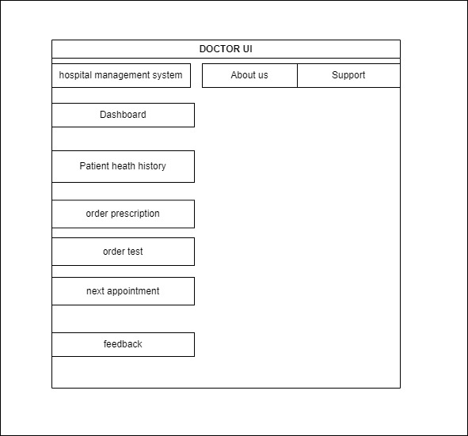

PATIENT UI:
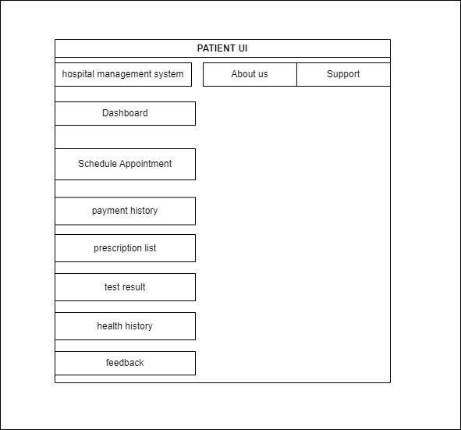

PATIENT HEALTH HISTORY:

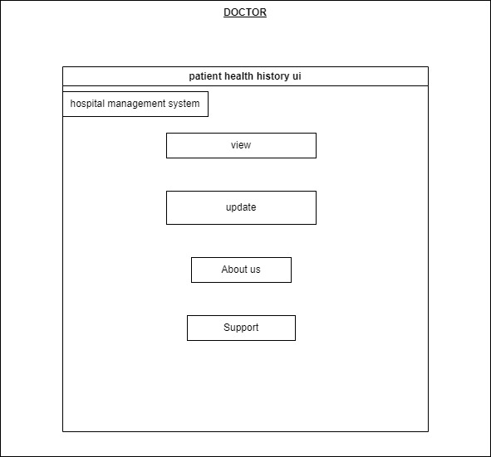

LABORATORY UI:
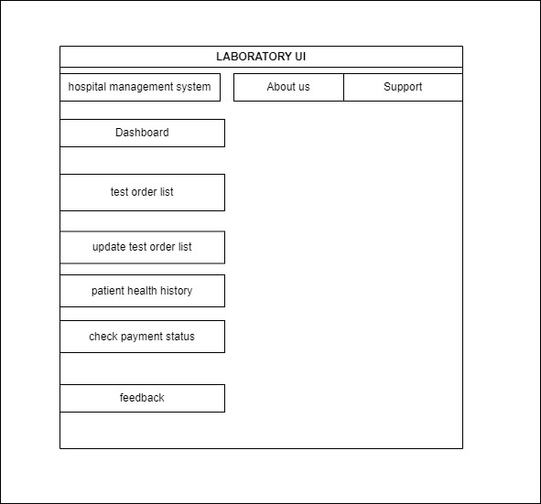

PHARMASIST UI:
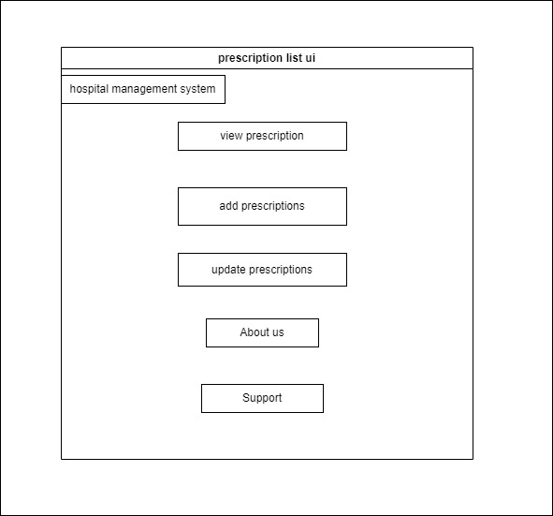

PRESCRIPTION UI:

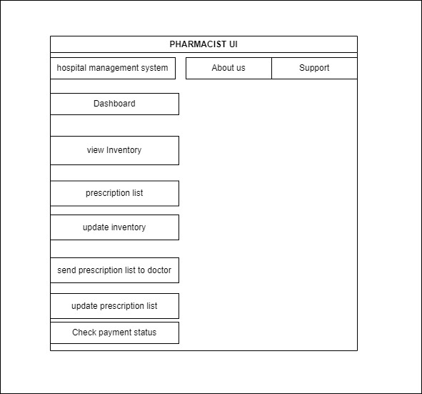

RECEPTIONIST UI:
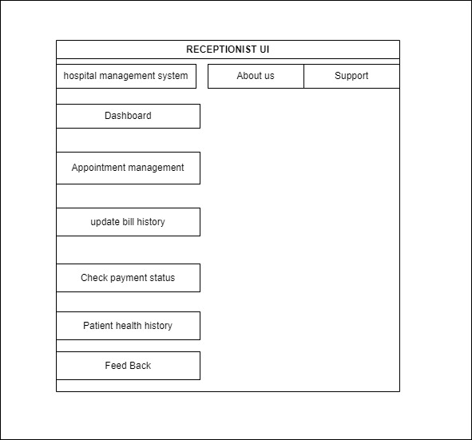

SCHEDULE APPOINTMENT UI:
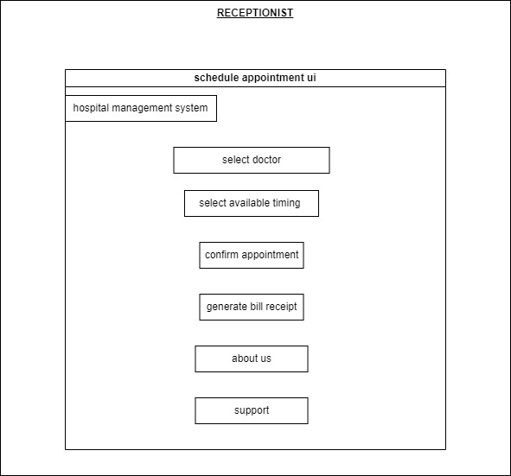

TEST RESULT UI:
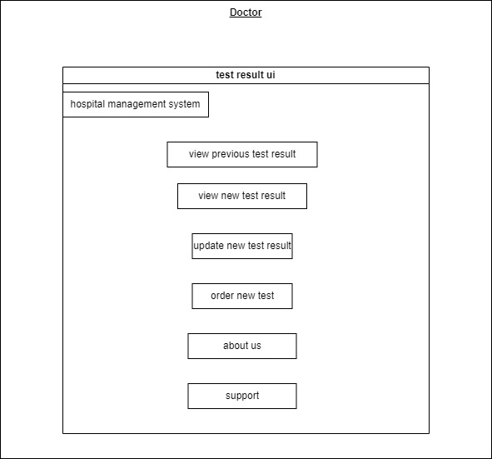

UPDATE BILL HISTORY UI:
